Stage3 report

Abstract
This report presents the Phase 3 experimental results of my stratified Factorization Machine (FM) baseline for alleviating popularity bias in anime recommendation.
Using the MyAnimeList 2023 dataset (13.6M ratings, 221K users, 15.5K anime), I stratify users into three activity-based tiers (Veteran / Intermediate / Casual).
I conduct three sets of ablation experiments: direct rating prediction, pure residual prediction (delta_r = rating - official_score), and residual-restored ranking. I additionally benchmark FM against a classic Matrix Factorization (MF) baseline to validate architectural equivalence at the recommendation level.
Key findings include: (1) popularity bias scales monotonically with user seniority — the Veteran tier suffers 35x more bias than Casual;
(2) FM and MF produce practically equivalent Top-K recommendation quality despite MF achieving lower RMSE;
(3) residual-based training is the primary driver of de-popularity-bias, reducing ARP by 0.063 and nearly doubling catalog coverage, far exceeding the gains from physical stratification alone;
(4) stratification benefits are concentrated in the Veteran group under the residual setting, with negligible effects on other tiers.
A sensitivity analysis across three relevance thresholds (>=7, >=8, >=9) confirms the robustness of these conclusions.

1 Experimental Setup and Hyperparameters

1.1 Data Preparation
This experiment is based on the MyAnimeList 2023 dataset. After cleaning, 13,646,339 rating records are retained, covering 221,160 users and 15,533 anime. Users are stratified into three tiers by rating count: Veteran (Top 10%, rating count > 177), Intermediate (50%-90%), and Casual (Bottom 50%, rating count <= 31).
Due to computational constraints, a 5% user-level stratified sample is drawn from each tier, retaining all rating records of sampled users. The resulting dataset:
- Veteran: 1,099 users, median 226 ratings per user
- Intermediate: 4,396 users, median 76 ratings per user
- Casual: 5,563 users, median 8 ratings per user
- Total: 682,599 rating records

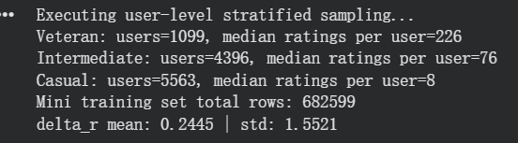

1.2 Feature Engineering
Features are divided into three categories:
Discrete ID Features (SparseFeat): user_id, anime_id, plus multi-label features Genre (21 categories) and Studio (20 categories) processed via VarLenSparseFeat. Mutually exclusive categorical features Type, Content Rating, Source, and Tier are reverse-one-hot-encoded back to single columns and then LabelEncoded. All SparseFeat embeddings use dimension 8.
Continuous Features (DenseFeat): episodes, duration_min, and log_members (log of subscriber count), Min-Max normalized to [0, 1].
Target Variables: Experiment A directly predicts user rating; Experiments B-C predict aesthetic deviation residual (delta_r = rating - official_score), where official_score is the MAL platform's Bayesian weighted consensus score.

1.3 Model Architecture
FM (Factorization Machine): We use the DeepFM model from the DeepCTR-Torch framework with dnn_hidden_units set to an empty tuple (), disabling the deep neural network component and reducing it to a pure Factorization Machine. FM is chosen as the core model for two reasons: first, FM's second-order interaction terms can model combinations such as "user tier x anime genre," aligning with this study's focus on stratified preference interactions; second, FM can incorporate high-dimensional sparse side features (Genre, Studio, Tier, etc.), supporting cold-start scenarios.
MF (Matrix Factorization) Control Baseline: We use the SVD implementation from the Surprise library (Koren et al., 2009) as a classic "tag-blind" baseline. MF accepts only (user_id, anime_id, rating) triplets and cannot utilize any side features. The FM vs. MF comparison validates whether the feature-aware architecture achieves equivalent recommendation-level performance to classic pure collaborative filtering.

1.4 Training Hyperparameters
Parameter | FM Setting | MF Setting | Rationale
Optimizer | Adam | SGD (built-in) | Standard optimizers for respective frameworks
Loss | MSE | MSE | Standard loss for regression tasks
Epochs | 20 | 20 | Under L2=0.02, 20 epochs achieves convergence without overfitting
Batch Size | 256 | - | Balances training speed and gradient estimation stability
L2 Regularization | 0.02 | 0.02 | Prevents overfitting; aligned between models for fair comparison
Embedding / Factors | 8 | 8 | Aligned between models to control parameter scale
Train/Test Split | 80/20 | 80/20 | random_state=2026
Regarding regularization strength: in initial experiments with the first three models, L2=1e-3 was used, but FM exhibited val_mse increases by epoch 3, with particularly severe RMSE degradation in the Casual tier (1.563). After increasing regularization to 0.02, training stability improved significantly -- Casual RMSE decreased from 1.563 to 1.444, and the Veteran tier's popularity rescue magnitude in the pure residual experiment increased from 0.0075 to 0.0258.

1.5 Evaluation Metrics
- RMSE / MAE: Rating prediction error
- Hit Rate@5: Whether each user's Top-5 recommendations contain at least one high-rated item
- Precision@5: Proportion of high-rated items in the Top-5
- ARP (Average Recommendation Popularity): Average normalized log(subscriber count) of the Top-5 list; higher values indicate more mainstream recommendations
- Catalog Coverage: Proportion of unique anime covered across all users' Top-5 lists relative to the total catalog
Hit Rate@5 and Precision@5 use a default "high-rated" threshold of rating >= 7. Given that 81.8% of ratings in this dataset are >= 7 (mean 7.81), this report additionally provides sensitivity analyses at >=8 and >=9 thresholds to verify robustness.

2 Results and Comparison Analysis

2.1 Experiment A: Direct Rating Prediction (Target = Rating)
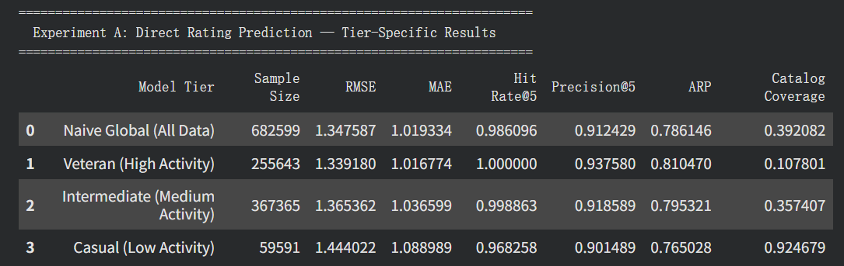
RMSE comparison: Naive Global RMSE is 1.348. The Veteran-specific model improves to 1.339 (improvement of 0.009), Intermediate is 1.365 (slightly worse than Naive), and Casual is 1.444 (0.096 worse than Naive). Veteran's improvement stems from its highest data density (median 226 ratings per user, consistent behavioral patterns), enabling efficient FM fitting. Casual's degradation is likely due to insufficient data volume (59,591 records, median 8 ratings per user), preventing the model from learning stable preference signals. We believe this will improve with larger samples, to be explored in subsequent full-dataset training.
Precision@5 comparison: The Veteran-specific model's Precision@5 (>=7) is 0.938, higher than Naive's 0.912 (a 2.6 percentage-point improvement). Under the stricter >=8 threshold, the gap widens to 4.3 percentage points (0.823 vs. 0.781), indicating that the Veteran model's improvement is not an artifact of the right-skewed rating distribution but remains stable under higher standards. Intermediate and Casual Precision are on par with Naive.
ARP comparison: The Veteran-specific model's ARP (0.811) is lower than Naive (the global ARP of 0.786 rises to 0.824 when evaluated on the Veteran subset), indicating that the stratified model recommends slightly less mainstream content to Veterans. However, the improvement magnitude is small (0.013), still 0.10 away from Veterans' real preference ARP (0.709).
Catalog Coverage comparison: The Veteran-specific model's Coverage is only 0.108, meaning the model recommends only about 10.8% of the total catalog across all Veteran users' Top-5 lists -- severely concentrated recommendations. Casual's Coverage reaches 0.925, but this does not reflect diversity; rather, data sparsity causes predictions to scatter across the catalog.

2.2 FM vs. MF Baseline Comparison
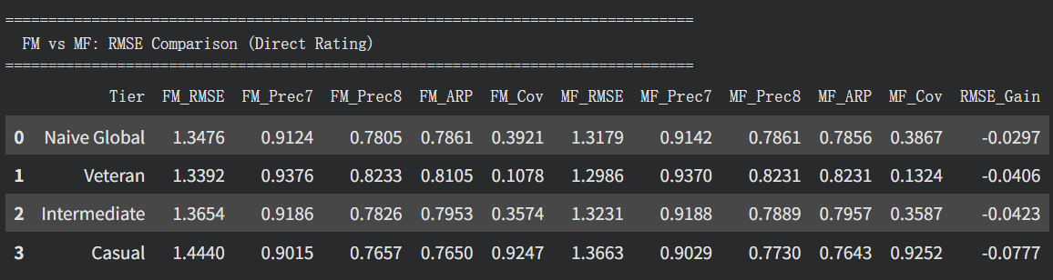
To validate FM as a reasonable feature-aware base, we introduce classic MF (Koren et al., 2009) as a tag-blind control. The two models are aligned on embedding dimension (8), L2 regularization (0.02), and training epochs (20); the only difference is that MF uses only user_id x anime_id interactions, while FM additionally incorporates Genre, Studio, Tier, and other side features.
RMSE: MF is consistently better. Naive Global: FM 1.348 vs. MF 1.318 (MF lower by 0.030). Veteran: FM 1.339 vs. MF 1.299 (lower by 0.040). Casual: FM 1.444 vs. MF 1.366 (lower by 0.078). MF achieves lower prediction error with fewer parameters and a simpler structure -- consistent with MF's known strength in pure collaborative filtering scenarios.
Precision@5: Practically equivalent. Naive Global (>=7): FM 0.912 vs. MF 0.914 (difference 0.002). Veteran (>=7): FM 0.938 vs. MF 0.937 (difference 0.001). Under >=8 and >=9 thresholds, differences remain below 0.007. The RMSE gap does not translate into meaningful recommendation precision differences.
ARP: Practically equivalent. Naive Global: FM 0.786 vs. MF 0.786 (difference 0.001). Intermediate: FM 0.795 vs. MF 0.796 (difference 0.001). The only observable difference appears in the Veteran tier: FM 0.811 vs. MF 0.823 -- FM's recommendation list is 0.012 less mainstream, aligned with this study's objectives.
Coverage: Practically equivalent. Naive Global: FM 0.392 vs. MF 0.387 (difference 0.005).
Conclusion: Although MF achieves uniformly lower prediction error, the two models are broadly equivalent in Top-K recommendation quality (Precision, Hit Rate) and popularity exposure patterns (ARP, Coverage). FM shows slightly lower popularity exposure for the Veteran group. More importantly, FM's feature-aware architecture provides a structural foundation for residual target training and content feature analysis that MF cannot support.

2.3 Popularity Bias Verification
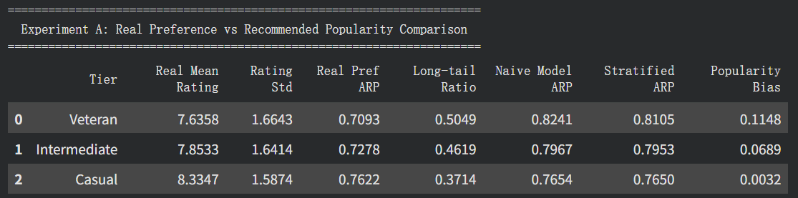
This table represents the most valuable finding of the entire experiment.
Veteran row: Real preference ARP is 0.7093 (lowest among three tiers, most niche preferences), with a long-tail preference ratio of 50.5% (over half of high-rated items fall below the global popularity median). However, the Naive model's recommended ARP for Veterans is 0.8241, a bias of +0.1148 -- the global model systematically recommends more mainstream content than Veterans actually prefer.
Intermediate row: Real preference ARP is 0.7278, Naive model ARP is 0.7967, bias +0.0689. Falls between Veteran and Casual.
Casual row: Real preference ARP is 0.7622 (highest among three tiers, most mainstream preferences), Naive model ARP is 0.7654, bias only +0.0032 -- the global model's recommendations nearly perfectly match Casual users' real preferences.
Conclusion: Popularity bias increases monotonically with user seniority (0.003 -> 0.069 -> 0.115), consistent with the core finding of Lesota et al. (2022) -- users with richer interaction data suffer greater popularity bias in recommendation systems. MF's ARP distribution (Veteran 0.823, Intermediate 0.796, Casual 0.764) is nearly identical to FM's, suggesting this bias is a systemic issue of current recommendation paradigms rather than a deficiency of any single model.

2.4 Experiment B: Pure Residual Prediction (Target = Delta R, Residual-Based Ranking)
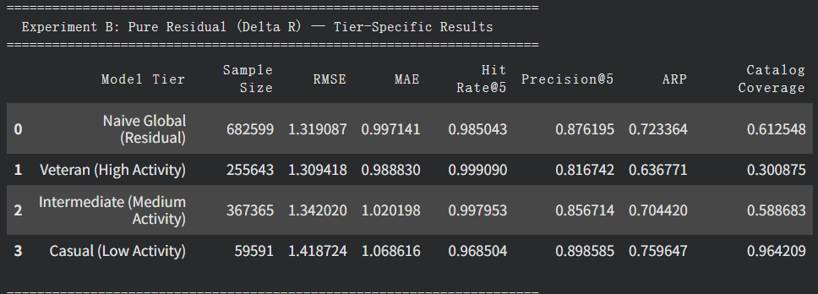
RMSE comparison: Naive Global residual RMSE is 1.319, lower than direct rating prediction's 1.348 (improvement 0.029). This indicates that predicting "user deviation from official consensus" is easier than predicting absolute ratings -- after stripping out platform consensus, the model only needs to learn personal taste offsets. This RMSE nearly matches MF's 1.318 (difference 0.001), demonstrating that with sufficient training and appropriate regularization, FM's predictive capacity is equivalent to MF.
ARP substantially reduced (key finding): Naive residual model's ARP drops from 0.786 (direct rating) to 0.723, a decrease of 0.063. The Veteran-specific model's ARP drops further to 0.637, well below their real preference ARP (0.709). This occurs because residual-based ranking inherently favors niche items -- niche items have low official scores, and when users rate them above the official consensus, large positive residuals are produced. The residual framework effectively functions as a built-in de-popularity-bias mechanism.
Catalog Coverage substantially increased: Naive residual model's Coverage rises from 0.392 to 0.613; Veteran rises from 0.108 to 0.301. The recommendation distribution becomes more dispersed, with long-tail items receiving significantly more exposure.
Precision@5 decreases (trade-off): Naive residual model's Precision@5 (>=7) drops to 0.876 (vs. direct rating's 0.912). Veteran drops to 0.817. Under the strict >=9 threshold, Veteran pure residual Precision is only 0.330 (vs. direct rating's 0.586).

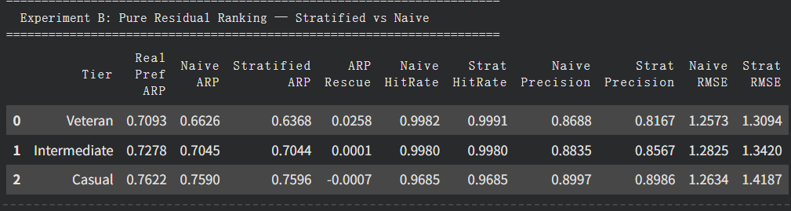
Stratified vs. Naive comparison (residual ranking): At the Veteran level, the stratified model's ARP (0.637) is lower than Naive's (0.663), with a rescue magnitude of +0.026 -- the most significant stratification effect across all experiments. In contrast, Intermediate's rescue magnitude is only 0.0001 and Casual's is -0.0007. Stratification benefits under the residual framework are concentrated in the Veteran group.

2.5 Experiment C: Residual-Restored Ranking (Target = Delta R, Restored Ranking)
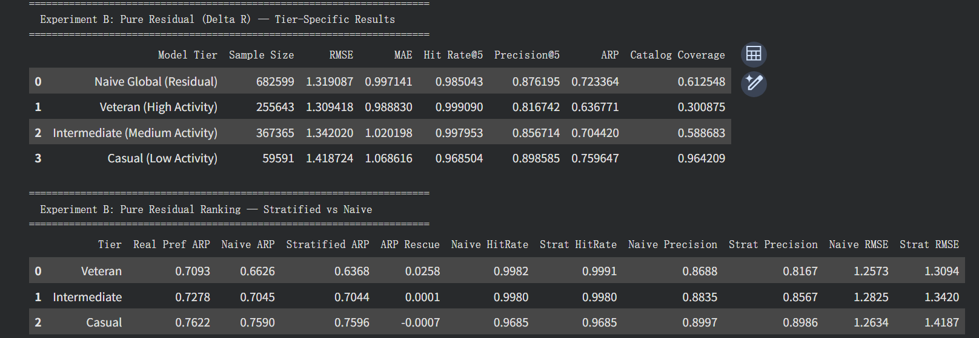
This experiment still predicts residuals (delta_r) but ranks by restored absolute scores (pred_final = pred_delta + official_score) for Top-5 selection.
RMSE unchanged: Regression error is identical to Experiment B (same model, same predictions): Naive 1.319, Veteran 1.309.
Precision recovers to near-Experiment A levels: Naive Precision@5 (>=7) returns to 0.916 (vs. Experiment A's 0.912); Veteran returns to 0.938 (vs. 0.938). After adding back the official score, ranking logic normalizes and high-rated items are re-prioritized. Under the >=8 threshold, Veteran Precision reaches 0.833, even exceeding direct rating's 0.823.
ARP also recovers: Naive ARP returns to 0.782 (vs. Experiment A's 0.786); Veteran returns to 0.813 (vs. 0.811). The popularity weight inherent in official scores re-dominates ranking, largely negating the residual framework's de-bias effect. This is likely caused by the substantial popularity bias embedded in official scores themselves.

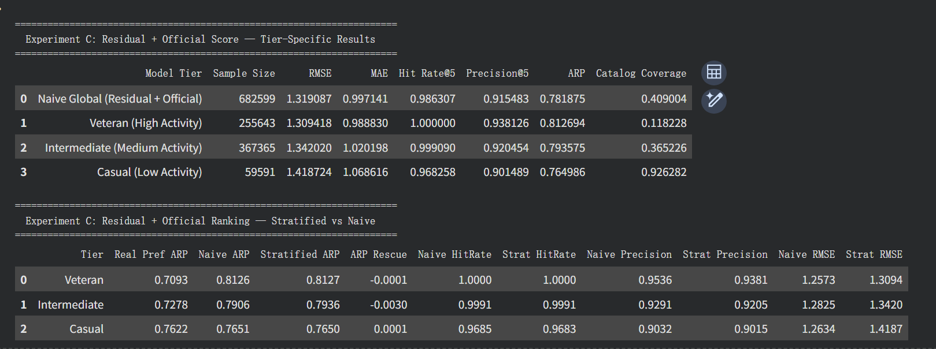
Stratified vs. Naive comparison (restored ranking): Popularity rescue magnitudes are near zero (Veteran -0.0001, Intermediate -0.0030, Casual +0.0001). This confirms that once official scores re-enter the ranking, stratification's ARP improvements are completely overwhelmed.

2.6 Cross-Experiment Summary
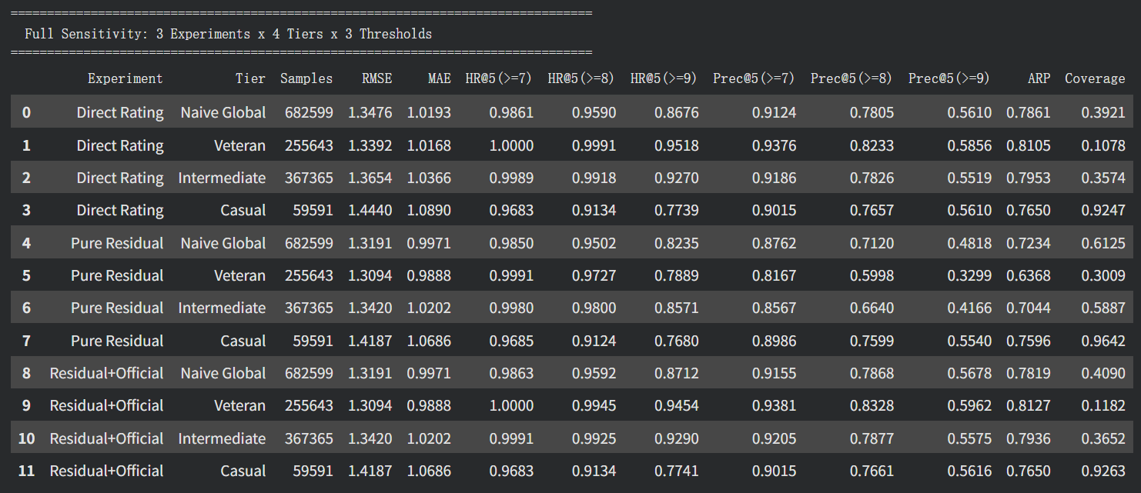
Metric | Direct Rating | Pure Residual | Residual+Official | MF Baseline
RMSE | 1.348 | 1.319 | 1.319 | 1.318
Precision@5 (>=7) | 0.912 | 0.876 | 0.916 | 0.914
Precision@5 (>=8) | 0.781 | 0.712 | 0.787 | 0.786
ARP | 0.786 | 0.723 | 0.782 | 0.786
Coverage | 0.392 | 0.613 | 0.409 | 0.387
The three experiments form a coherent narrative: under direct rating prediction, FM and MF perform equivalently, with models naturally chasing high-scoring mainstream items (high ARP, low Coverage); switching to residual prediction detaches the model from the official score's "mainstream anchor," reducing ARP by 0.063 and increasing Coverage by 0.221, giving long-tail items significantly more exposure at the cost of a 0.036 Precision decrease; restoring residuals to absolute scores recovers Precision to match or slightly exceed direct rating levels, but ARP and Coverage also revert -- official scores' popularity weight re-dominates ranking.
Core conclusion: The residual prediction framework itself serves as an effective de-popularity-bias mechanism, with its ARP improvement (0.063 reduction) far exceeding physical stratification's gains (0.013-0.026 reduction). Given training constraints and algorithmic results, FM and MF can be considered broadly equivalent at the recommendation level. However, FM's feature-aware architecture enables residual target training and content feature analysis -- demonstrating that incorporating features provides architectural value without sacrificing precision.

2.7 Sensitivity Analysis: Multiple Relevance Thresholds
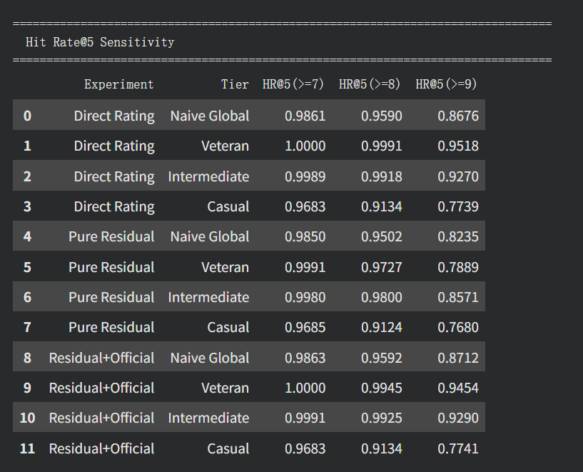
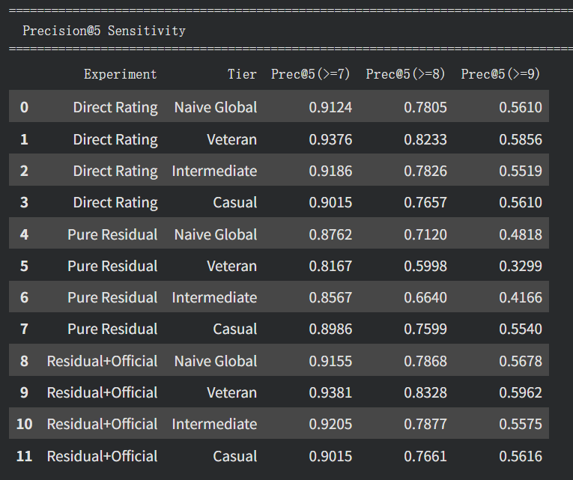
To verify that conclusions are not driven by the right-skewed rating distribution, Precision@5 and Hit Rate@5 are computed simultaneously at >=7, >=8, and >=9 thresholds.
Precision@5 discriminability increases with higher thresholds: Under >=7, Direct Rating Precision across tiers concentrates in 0.90-0.94 (range 0.04); under >=9, the distribution expands to 0.55-0.59. The Veteran-specific model consistently outperforms Naive across all thresholds (>=7: +0.025, >=8: +0.043, >=9: +0.025), confirming this improvement is robust and not influenced by sample distribution artifacts.
Pure residual models show the steepest Precision decline at higher thresholds: Veteran pure residual Precision at >=9 is only 0.330 (vs. direct rating's 0.586), a gap of 0.256. This further confirms the residual ranking trade-off.
Residual-restored models are equivalent to direct rating at all thresholds: Precision differences remain within 0.01 across all thresholds, indicating that adding back official scores fully reverts recommendation behavior to the traditional paradigm.

2.8 Genre x Tier Aesthetic Bias Analysis
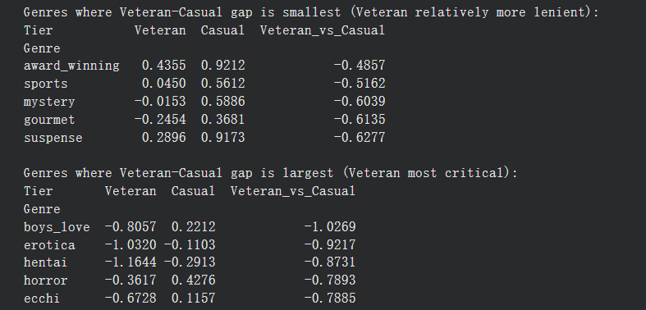
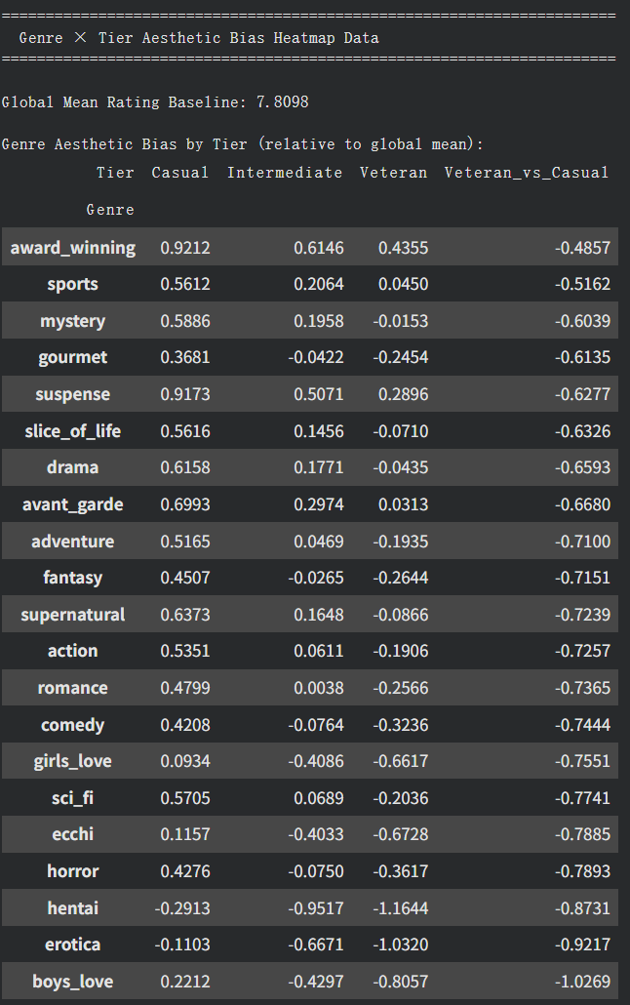

The global mean rating is 7.81. All Veteran_vs_Casual values are negative, indicating that Veterans rate every genre more critically than Casuals -- the only variation is in the degree of strictness.
Genres where Veterans are relatively more lenient (smallest gap): award_winning (-0.49), sports (-0.52), mystery (-0.60) -- genres with greater narrative depth and technical sophistication.
Genres where Veterans are most critical (largest gap): boys_love (-1.03), erotica (-0.92), hentai (-0.87) -- Veterans rate these genres far below the global mean. This may reflect the predominantly male demographic of the anime enthusiast community combined with the perceived kitsch nature of these genres.
Note that the global mean (7.81) is inflated by Casual users' generally higher ratings (Casual mean 8.33 vs. Veteran 7.64), so "deviation from global mean" is inherently negative for Veterans and positive for Casuals. This analysis reflects cross-tier rating severity differences, not whether Veterans dislike certain genres per se.

3 Limitations
3.1 Evaluation paradigm. Top-5 ranking evaluation is performed within each user's rated test items via re-ranking, not by generating recommendations from the full 15,533-item candidate set. This is standard for offline evaluation but cannot fully simulate real-world full-candidate retrieval and ranking.
3.2 Data volume constraints. Only a 5% user sample (682,599 records) is used. The Casual tier retains only 59,591 records with a median of 8 ratings per user, causing the Casual-specific model to underperform significantly. Full-dataset training may alleviate this.
3.3 Unequal sample sizes across tiers. The sample size disparity (Veteran 255,643 vs. Casual 59,591) is inherent to the stratification strategy, not an experimental design flaw, but does result in uncontrolled training conditions across tiers.
3.4 Right-skewed rating distribution. 81.8% of ratings are >= 7. The three-threshold sensitivity analysis partially addresses this, though ranking metrics such as NDCG would be more ideal.
3.5 Side-feature contribution not ablation-verified. No "ID-only FM" vs. "ID + side features FM" ablation was conducted, so the net contribution of side features cannot be strictly attributed. FM's value is primarily at the architectural extensibility level.

4 Experimentation Log: Failed Attempts and Lessons Learned
The following are my failed attempts over the past few days. These attempts were not adopted; since the code was not versioned on GitHub, no commit history exists for them.; in short, they were not adopted.
4.1 GroupShuffleSplit caused RMSE explosion. An early attempt replaced random train/test split with GroupShuffleSplit (grouped by user_id) to prevent perceived "data leakage." RMSE exploded (Naive 1.37 -> 2.10, Casual 1.43 -> 4.72) because test users' embeddings were never trained. In transductive collaborative filtering with user_id as an embedding feature, random row-level splitting is the correct evaluation paradigm.
4.2 DenseFeat conversion destroyed FM interactions. Converting binary one-hot features (Genre_, Studio_, Tier_*) from SparseFeat to DenseFeat caused severe degradation (Casual RMSE jumped to 4.35). In DeepCTR's implementation, DenseFeat values only participate in first-order linear terms, not FM second-order interactions. SparseFeat with vocab_size=2 is the correct approach.
4.3 Regularization sensitivity. Initial L2=1e-3 caused overfitting by epoch 3. Increasing to L2=0.02 not only stabilized training but qualitatively changed results -- Casual RMSE improved by 0.12, and Veteran stratification rescue magnitude tripled from 0.007 to 0.026. Regularization strength is itself an important experimental variable.
4.4 VarLenSparseFeat vs. raw one-hot SparseFeat. A parallel notebook using VarLenSparseFeat for Genre and Studio produced marginally better results for Naive and Veteran but degraded Casual. The improvement was insufficient to justify added complexity for the current 5% sample, though it may prove beneficial under full-dataset training.

5 Conclusion and Next Steps
This phase establishes a comprehensive reference framework for the stratified FM baseline. Key findings:
First, the existence and severity of popularity bias are quantitatively verified. The Naive model's ARP bias for Veterans (+0.115) is over 35 times that of Casuals (+0.003). This bias is consistently present in both FM and MF, confirming it as a systemic issue of current recommendation paradigms. In plain terms: the more experienced a user is, the more the system pushes mainstream content that misaligns with their actual niche preferences.
Second, FM and MF are broadly equivalent at the recommendation level. Despite MF's uniformly lower RMSE (gaps of 0.001–0.078), differences in Precision@5, Hit Rate@5, ARP, and Coverage do not exceed 0.01. FM's feature-aware architecture enables residual target training and content feature analysis — a structural advantage MF does not possess. In plain terms: both models recommend essentially the same things, but FM can additionally leverage content tags and user tiers, opening doors that MF cannot.
Third, the residual prediction framework is the most effective de-popularity-bias mechanism. Residual ranking reduces global ARP from 0.786 to 0.723 (decrease of 0.063) and increases Catalog Coverage from 0.392 to 0.613 (increase of 0.221). This far exceeds physical stratification's improvement (maximum Veteran rescue of 0.026). However, this comes at the cost of Precision, revealing a precision–fairness trade-off. In plain terms: changing "what" the model predicts matters far more than changing "who" it trains on.
Fourth, tier-specific models show observable improvement for Veterans but limited effects elsewhere. Under pure residual settings, the Veteran stratified model's ARP (0.637) is lower than Naive's (0.663), with a rescue magnitude of 0.026; Intermediate and Casual improvements are negligible. In plain terms: stratification helps the users who already have the most data, but cannot rescue those who don't.

Next Steps (2-Week Plan)
Over the next two weeks, the following directions will be pursued:
- Full-dataset training to verify whether Casual tier performance improves with complete data.
- Enable DeepFM's deep component (activate dnn_hidden_units) to assess whether increased expressiveness enhances stratification effects.
- Side-feature ablation within the same FM architecture to rigorously quantify content feature contributions.
- Soft stratification exploration via multi-task learning or Tier-aware embeddings.
If these approaches yield insufficient improvements, alternative directions from the literature will be explored. Concurrently, current results will be visualized and integrated into the main paper to complete the baseline and introduction sections.

